Programming, Tech Stacks & Product Mindset
Class 0 — what programming really is, why so many technologies exist, and how to think like a builder
Class: 0 · Format: Lecture + 2 quizzes + doubt session
Why this matters: This class is not about syntax. It is about the two things that separate someone who copies code from someone who engineers solutions: knowing how to pick your tools, and knowing who you are building for.

What you should be able to do after this
- Explain what programming actually is, and what a programmer is really paid for
- Name the common stacks and say why more than one exists
- Choose a stack using pros/cons plus the scale and lifecycle of the project
- Say why this course uses MERN
- Look at any product and ask who it was built for

What's inside
1. What is programming?
2. What are you actually paid for?
3. The stacks that exist
4. Why do we need so many technologies?
5. How to choose a stack
6. Why MERN for this course
7. Product mindset

1. What is programming?
In one line: A medium to tell a computer how to solve a problem.
Think of it like: It is a language. We use English or Hindi with each other, but a computer does not understand those — so code is the shared language we use with it.
Key points
- Programming = giving a machine instructions it can act on.
- You are not learning to type syntax.
- You are learning to think in a way that lets you tell a machine how to solve a problem.
- That thinking is the part that transfers to every language you ever learn.
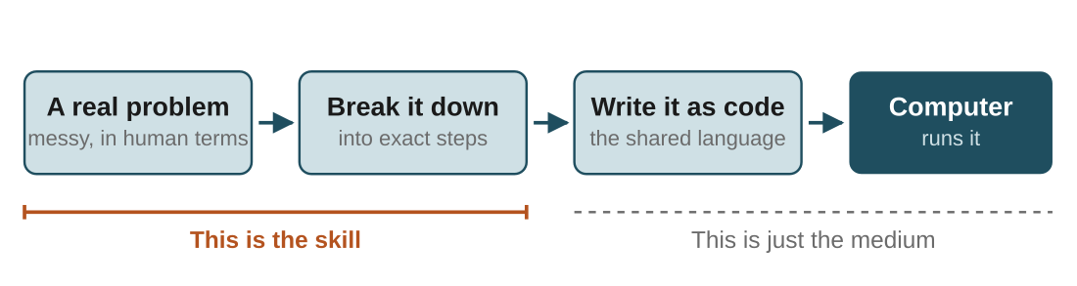
Figure 1 — the hard part is on the left. Turning a messy problem into exact steps is the skill; writing it as code is the medium.
In the real world: You want to sort 500 names. You already know how to do it by hand. Programming is writing down that method precisely enough that a machine can follow it without asking you a single question.
Watch out: "AI can already write code and understand English — so why learn this?" AI generates code, but it still needs someone to direct it, verify it, and fit it into a larger system. The person who understands the problem, the structure and the trade-offs is the one steering. Learning to program is what lets you steer it, and use AI far more effectively than blindly trusting its output.
Your notes

2. What are you actually paid for?
In one line: Not for lines of code — for removing friction that costs a business time or money.
Key points
- Surface answer: programmers are paid to write code. That is not the value.
- Solving real problems — turning a messy human need into a working solution.
- System design — structuring solutions so they are reliable, scalable, maintainable.
- Making businesses faster — automation that makes a process 10x quicker, cheaper, or less error-prone.
- Code is the medium. Spotting where things are slow or broken is the value.
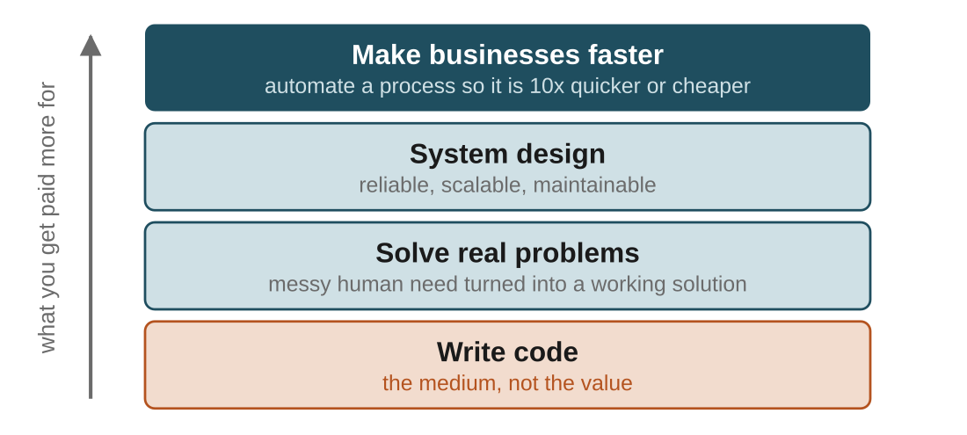
Figure 2 — the ladder you climb over a career. Everyone starts at the bottom rung; almost nobody is paid well for staying there.
In the real world: Look at any business and find the step someone does by hand every single day — reconciling two spreadsheets, copying orders into a tracker. Build the thing that removes it. That is the whole job, compressed.
Watch out: Most people spend their entire first year learning only "how to program". This course also teaches you how to choose your tools and think like a builder from early on — that mindset is the differentiator.
Your notes

3. The stacks that exist
In one line: A stack is just the combination of technologies you use to build a product.
Key points
- Usually frontend + backend + database, plus supporting tools.
- There is no single "correct" stack.
- Different combinations exist because different problems have different needs.
- You will hear these names constantly — recognise them, don't memorise them yet.
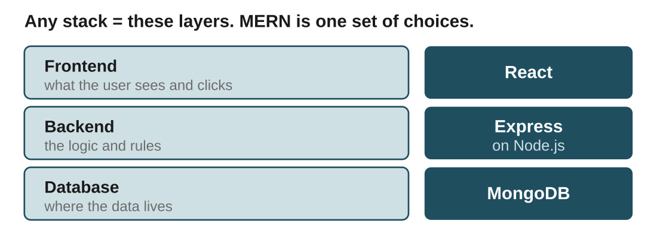
Figure 3 — every stack fills the same three slots. Swap any one box and you have a different stack with a different name.
Terms to know
- MERN — MongoDB, Express, React, Node.js. All JavaScript. Great for fast web app development
- MEAN — the same as MERN, but Angular instead of React
- LAMP — Linux, Apache, MySQL, PHP. One of the older, battle-tested web stacks
- Java + Spring Boot — very common in large, mature enterprises for robust backends
- Python + Django / Flask — popular for rapid development, data-heavy apps, and ML-adjacent work
Your notes

4. Why do we need so many technologies?
In one line: Because different tools are efficient for different jobs.
Think of it like: A carpenter cutting a board can reach for a hand saw, a chainsaw, an axe, a precision saw or a drill. Several of them will cut it. A good carpenter knows which one fits this cut — you would not use a chainsaw for fine work, or a precision saw to fell a tree.
Key points
- The skill is not knowing one tool. It is knowing which tool fits the problem.
- Small scale → the tool barely matters. Tic-Tac-Toe can be built in almost anything.
- Huge scale → the tool decides what is possible. GTA 6 demands raw speed, so a game engine and C++.
- The tool you choose defines what is possible and how efficiently you can do it.
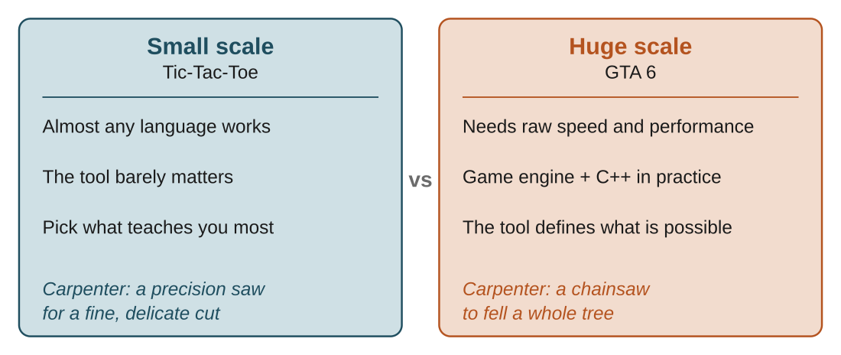
Figure 4 — same task, different scale, different right answer. Notice that both columns are legitimate choices; only the context decides.
In the real world: From the industry: Blizzard builds custom game engines fine-tuned to its games, while a studio making a simple card game just uses Unity off the shelf. Apple builds its own OS tuned to its hardware, and now designs its own silicon so software and hardware match perfectly.
Watch out: The legend worth remembering: Chris Sawyer wrote most of RollerCoaster Tycoon in assembly language. By picking an extremely low-level, high-performance tool, he got a game running smoothly on the limited hardware of that era — something that would have been very hard otherwise.
Your notes

5. How to choose a stack
In one line: Ask what the stack's pros and cons are, then ask what scale and purpose your project has.
Key points
- Two questions, that is it: pros/cons of the stack, and scale + purpose of the project.
- Learning project → pick whatever teaches you the most.
- Real product → weigh performance, speed of development, team skills, and how it will grow.
- Software development as a lifecycle: the stage a product is at maps to the stack that suits it.
- Early-stage startup → things change constantly, ship prototypes, get feedback, pivot. Wants speed and flexibility.
- Mature company → past PMF, needs extreme reliability at scale. Evolves toward more mature but less flexible stacks.
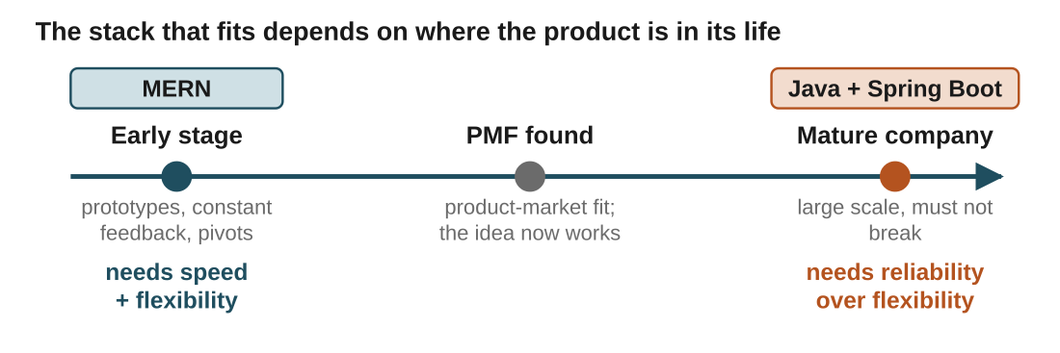
Figure 5 — the same product can want a different stack at different points in its life. Choosing then feels logical instead of random.
In the real world: An early-stage startup rewrites a feature three times in a month because users keep telling them it is wrong. A bank's core backend cannot be rewritten three times in a month. Same industry, opposite requirements.
Terms to know
- PMF (Product-Market Fit) — the point where the product has proven that a real market wants it
Your notes

6. Why MERN for this course
In one line: It matches where you are — learning and building fast — and how early-stage products are actually built.
Key points
- Speed of building prototypes. Startups live and die on how fast they can build, test and change an idea.
- Flexibility. When something breaks or the plan changes, you can pivot without rewriting everything.
- One language everywhere. JavaScript on the frontend (React) and the backend (Node) — learn one language, use it across the whole stack.
- That last point matters most while you are building your foundation.
In the real world: As a product matures and needs rock-solid reliability at scale, a team might later add or move to something like a Java backend. MERN is where the journey starts, not where it is required to end.
Watch out: MERN is not "the best stack". It is the best fit for your current stage. Anyone who tells you one stack wins every time has skipped the question of scale and lifecycle.
Your notes

7. Product mindset
In one line: Building things other people can actually use — and always knowing who those people are.
Key points
- The most valuable habit beyond writing code.
- Start by scratching your own itch — build small things that make you 10x more effective.
- These small builds teach you more than any tutorial.
- The depth is understanding persona and audience. A product is something that gets sold, so: who is this for?
- Who is the audience for Apple? Who was the audience for a game like Far Cry 3?
- Pick anything in the room — a phone, an app, a chair — and ask who it was made for and what problem it solves.
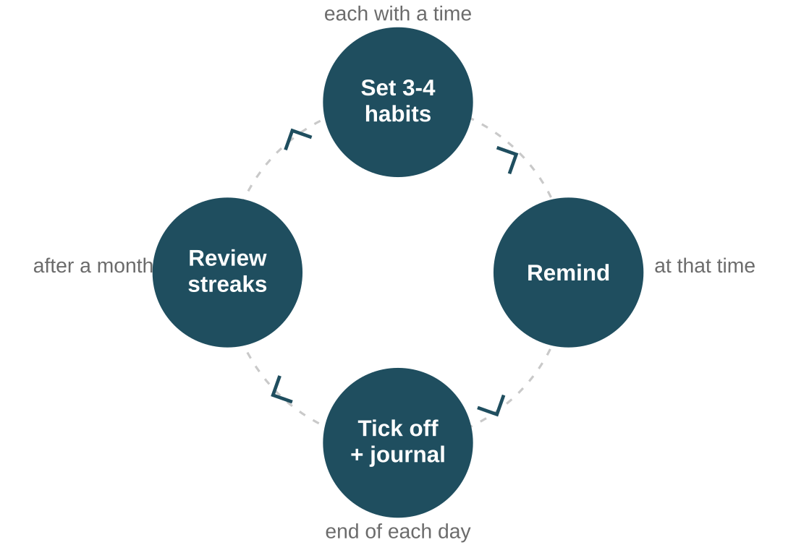
Figure 6 — the habit tracker from class. One small app, and it makes you build the full loop: design, logic, and user experience.
In the real world: The atomic habit tracker: ask the user for 3-4 daily habits and a time for each → send a reminder at that time → at day's end, tick off what was done with space for notes and journalling → after a month, show results and streaks.
Watch out: Once you see the world this way, programming stops being syntax. It becomes a set of tools to build things people want — and you become the engineer who picks the right tool, builds the thing, and increasingly directs AI to do it faster.
Your notes

Quick recap
- Programming is a language to tell computers how to solve problems.
- You are ultimately paid to solve problems and make systems and businesses faster.
- Many stacks exist because different tools fit different jobs — the carpenter choosing the right saw.
- Choosing a stack comes down to pros/cons and the scale and lifecycle of the project.
- We use MERN because it gives speed and flexibility while we learn and build.
- A product mindset means building things people can use — scratch your own itch, and always ask "who is this for?"

Try it yourself
- Self-check: at the highest level, what is a programmer primarily paid to do?
- Self-check: why is MERN often recommended for early-stage products and learners?
- Start one tiny personal project this week. Not polished — just something that makes you slightly more effective.
- Pick three things you used today and write down, for each, who it was built for and what problem it solves.
Your notes

